Murder Mystery Themes
Heavy Metal Homicide
Slasher, the big hair band of 80’s heavy metal music, is celebrating the achievement of their recent Platinum Album, “Cut Throat!” BHB Music, Slasher’s record label, is throwing a party in their honor and will be presenting the band their award. This will be the party of the year in Hollywood and you have received an invitation! Famous musicians, actors and other A-list celebrities are just some of the individuals who made it on the suspect guest list for the evening, so pull out your sparkles & spandex and hope you aren’t the one who ends up dead on the Red Carpet!

Deadly Verses of Love (Valentine’s Day)

Love is in the air (or you would think..)
After staggering to the stage and uttering a few cryptic words, one member of The Poets Turntable, is overtaken by death. Someone here
has “done in” a fellow member during one of the year’s most anticipated special events, Valentine’s Day! This annual gathering, comprised of
both amateur and professional poets, is traditionally filled with amore’ –
yes, LOVE. Each poet rises and romances the audience with words and metaphors that help even the coldest of hearts beat faster. But now, in the midst of the tearful tragedy, poetic justice shall be served as all of you here will gather to investigate the death and discover the culprit who turned this holiday into a bad rhyme.

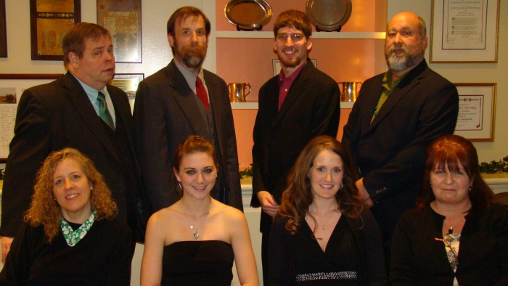
Murder Most Green (St. Patty’s Day)
This special holiday murder mystery takes place in the City of Blarney. Your guests are invited to a St. Patrick's Day party to honor Patrick Flaherty, owner of Flaherty's True Green Plant Nursery. When they arrive, they find out that Flaherty died the previous night after a get-together that celebrated the nursery's centennial year. Instead of having a party, your guests will be attending his wake. Family members and acquaintances pay their respects to Flaherty and, in the process, drop hints that Flaherty's death might be more than accidental. An undercover member of the local police force, who believes that foul play is prevalent, leads the homicide investigation.
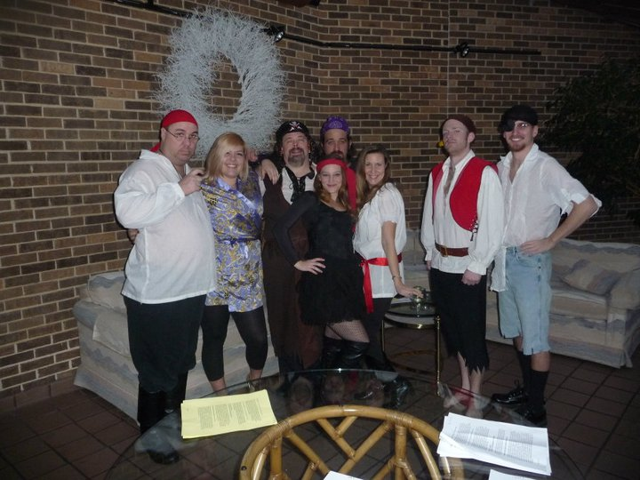
Pirates

Ahoy, me hearties! Forgive the informalities, but as your Captain, I have known most of you for many a year, serving aboard this beloved pirate ship of mine, and a better collection of black hearted sea dogs I couldn’t have wished for.

Known you yes, but trusted you – no! For, if you are reading this instead of us all enjoying a flagon of rum together, it is because one of you has seen fit to murder me most fouly. I have a good inkling as to why I’ve been done in, but now it’s left to you, me shipmates, to work out which of you had a good enough reason to want me dead. Until the mystery is solved, none of you will be able to sleep soundly in your hammocks....

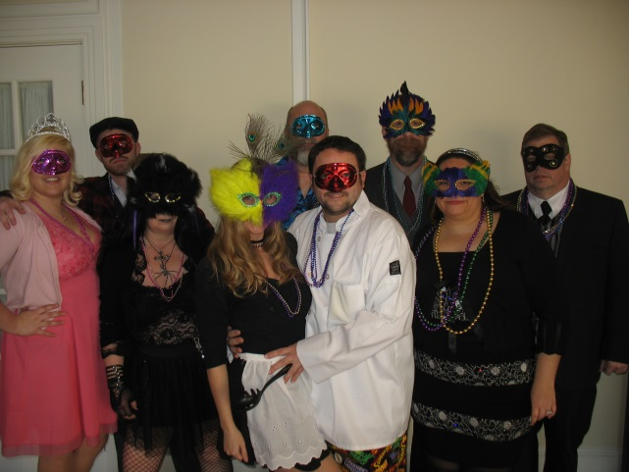
Big Lies in “The Big Easy”

It’s Mardi Gras in The Big Easy and an annual masquerade ball is in full swing. It’s a night of gossip, glamour, and MURDER. There are some old scores that need to be settled, as well as family secrets to be revealed. Who killed the Mardi Gras King with a priceless vintage necklace?

Did someone conspire to kill the old man and inherit his millions? Or, was it his young wife? Did his lawyer or his personal chef kill him to pursue wealth and power? Was it his next door neighbor, the eccentric gothic novelist? Perhaps it was the French maid who knew too much. So, don your costume, hang your beads, grab a Hurricane, and solve the crime!
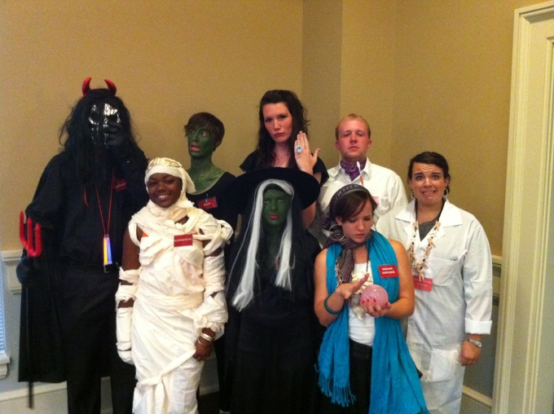
A Night to Dismember

It’s Halloween, and the angry voices you may hear just outside the castle gate are the townsfolk, and by the look of those torches and pitchforks, I don’t think they’re here to Trick-or-Treat. They believe there are witches, ghouls, and various other creatures of the night herein the cadaverously cold chambers. But that’s not the worst of it. I regret to have to inform you that your host is dead -murdered by one of you. floor of the East-facing sunroom, his body burnt to a crisp.

The Tragical “Tripp” – a far out 1960’s Murder Mystery that’s Outa Sight

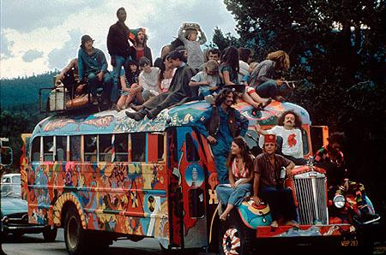
Whoa, dudes. What a head rush. I’ve never seen a bus blow up before. At least, you know, not while I was sober. Sorry to be a drag, but I’m afraid I have some real uncool news for you. The hippest rock singer of the 1960’s, just got herself a heavy dose of instant karma. She was on that ballistic bus man, and I know you all must be in deep shock and emotional denial, but before you start to meditate on your transcendence to a higher plane, there are some things we need to rap about. The real fuzz will be here soon, so I suggest we hang loose and work together. Peace baby!

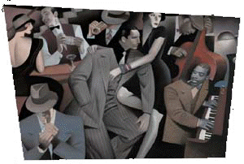
The Chicago Caper
Prohibition has been in force since 1920 but it1s not hard to find a drink in this town. Alcoholic beverages can be had for the asking in thousands of speakeasies, restaurants and bars throughout the city. Fine imported wines and liquor, locally brewed beer and "alky" cooked in private homes are served regularly in astonishing quantities. "lt's just plain fun," says a prominent Chicago flapper, twirling her beaded necklace and moving in rhythm to the beat of a Chicago jazz band. "After all, as long as nobody's getting' hurt, what's really wrong with a little crime now and then?"

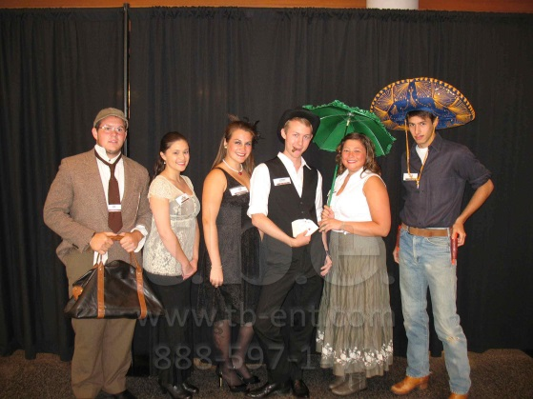

I Shot the Sheriff?
It is the wild west in the year 1872. On a clear July morning, dawn is just breaking over the tiny frontier town, when a single gunshot rings out. The townsfolk rush to the scene and are horrified to find their sheriff, sprawled in the dust, dead from a gunshot wound. He was apparently bushwhacked from behind.

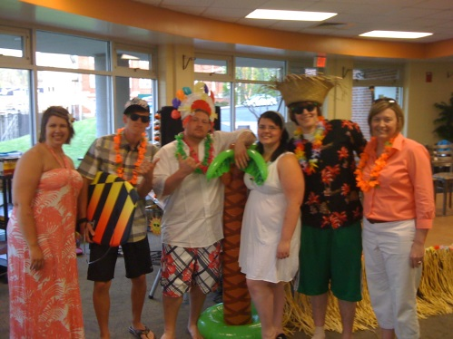
Murder in Maui
Aloha, and welcome to Hawaii! I hope that everyone has been greeted in the true Hawaiian spirit of Ho-okeepa, as is our custom, here on the island of Maui.
As guests, you came here tonight for a beach luau on this private estate to celebrate the birthday of our friend, Chase. I was very sad when I heard that Chase DIED suddenly, less than an hour ago, from the effects of a fatal poison. It is no secret that he had enemies.

Stayin’ Alive
Ah-whoooooo! It's Wolfguy Jake, comin' to ya live from the world of intrigue and murder. What a lineup of entertainment we have for you, my little pack of wolves and wolfettes. We're goin' to howl tonight. Ah-whooooool I can tell you're all feelin' a little tense arid all, bein' penned up here at Studio Manhattan. What with the buildin' bein' closed down and declared a crime scene by New York's finest. That's right, a genuine certified crime scene. Because, as you know, the club's owner, that sweet, sweet lady, Jackie Fever, was murdered right here last night. Yes, folks, she's gone to the great wolf den in the sky.

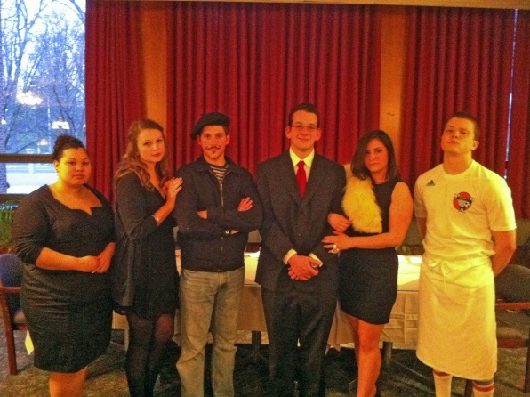
A Lethal Lasagna

Bon Giomo! We are here in Little Italy at La Sperenza, one of New York City's most renowned Italian eateries. The restaurant sits on a quiet, tree-lined street and it usually has a peaceful clientele. Four nights ago, however, it was the scene of a murder!

Leaving Las Vegas
Hey, folks, how y'all doin'? Welcome to Las Vegas, Nevada. Please step inside the Pearly Gates Gamblin' Emporium for a chat about a serious we had today. The management here at the Emporium has been kind let us use a private suite so we won't be disturbed. You see, the owner of this fine establishment, Black Jack White, murdered today at the Love Me Tender Chapel.

The Return of Rock N. Roley
It Is Friday night, October 29, 1959. You are in Maltie's malt shop in the small town of Roley City, near the thriving metropolis of Roley City. You are all in your early 20's (I know it's a stretch for some of you, so PRETEND!) and graduated from Roley City High School slightly more than five years ago. The people with you are friends from high school and although a party is in progress, not all is well. Some of your friends seem anxious despite their gaiety; you seem to be having a case of nerves as well. Your classmate, the internationally famous rock 'n' roll star, Rock N. Roley, is expected any minute.

Who Stole the Stars?
It is the golden age of Hollywood. The year is 1939 -a milestone year in the history of American cinema. Gone with the Wind, The Wizard of Oz, and Goodbye, Mr. Chips all premiered this year. But the biggest and most anticipated extravaganza of them all is the Mogul Films' production of Come with the Rain, an epic of the American West, and a film with which some of us present are intimately connected. The setting is the posh Bel Air mansion of the president and primary owner of the Mogul Films empire, Benny Sahlinsky. Tonight guests have been invited to view the first screening of Come with the Rain, a film upon which rests the future of Mogul Films. This saga of the Old West was produced for the nearly unheard of sum of $6 million. The film is to be the definitive epic of the war between settlers and cattlemen. It climaxes when the entire town of Travers City is obliterated by a gigantic explosion. The explosion is set off by sadistic cattle barons who then unleash a herd of 500,000 raging steer who stampede through the bumming rubble, annihilating everything in their path. It is the most tremendous and realistic scene of total destruction ever filmed

